Date : Thursday, November 5, 2015

**Index Naming Conventions**

**Rules for Creating Index**

* There should be clustered index on each table in database, and usually on Primary Key.
* Covering index should be created on frequent queried columns.
* Total Number of Index Columns Should be Maximum 7.
* Following Index naming standards should be followed.

**Type of Indexes**

|  |  |  |
| --- | --- | --- |
| 1 | PKCX | Primary Key Clustered Index |
| 2 | PKNC | Primary Key Non Clustered Index |
| 3 | CX | Clustered Index with Single Key Column , without any included columns |
| 4 | NC | Non clustered Index with Single Key Column, with or without any included columns |
| 5 | CVCX | Covering Clustered Index, with more than 1 key column and without included columns |
| 6 | CVNC | Covering Non Clustered Index, with more than 1 key column and without included columns |
| 7 | FLCX | Filtered Clustered Index |
| 8 | FLNC | Filtered Non Clustered Index |
| 9 | CS | Column store indexes |

**Type of Index Column**

K - Key Column

I - Included Column

**So Typical Index would look like below**

<Type of Index>_<TableName>_< COL1 (Type Of Index Column ) > _ < Col2 (Type Of Index Column)

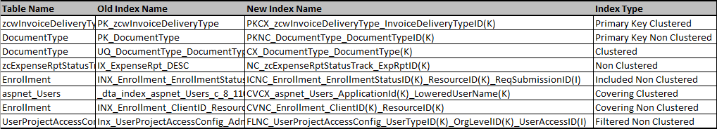**Sample**